Membership Payment System - Flowcharts
SYSTEM FLOWCHARTS
WEB APPLICATION
Process Flows & System Architecture
Prepared by:
Sunsys Technologies Pvt Ltd
Version: 1.0
Date: January 2026

TABLE OF CONTENTS

1. System Overview ........................................... 3
2. Technology Stack ........................................ 3
3. Complete System Flowchart .................... 4-5
4. Payment Logic Flowchart ........................ 6
5. Membership Year Rules ............................. 7
6. Database Schema ....................................... 8
7. API Endpoints ............................................. 9
8. User Journey ............................................... 10

1. SYSTEM OVERVIEW
This document provides comprehensive flowcharts for the Membership Payment System web application. The system enables users to search for members, view their details, and process membership payments with automatic year-wise validation.

1.1 Key Features
• Member Search: Quick search by name with instant results
• Member Verification: Display complete member details including Folio Number
• Sequential Payment Validation: Ensures no membership years are skipped
• Payment Gateway Integration: Secure online payment processing
• Automatic Membership Activation: Instant activation upon successful payment

2. TECHNOLOGY STACK
Layer | Technology
Frontend | React with Vite (JavaScript framework for UI)
Backend | Node.js (Server-side API and business logic)
Database | MySQL (Relational database for member and payment data)
Payment Gateway | Razorpay / Stripe (Secure payment processing)

3. COMPLETE SYSTEM FLOWCHART
This flowchart illustrates the complete end-to-end flow across Frontend (React), Backend (Node.js), and Database (MySQL) layers. The diagram is divided into two parts for clarity.

3.1 Part 1: Member Search to Payment Gateway
The first part shows the user journey from website access through member search, verification, payment history validation, and membership year calculation, up to the payment gateway.

3.2 Part 2: Payment Processing & Completion
The second part continues from the payment gateway, showing both payment success and failure paths, database updates, membership activation, and final user feedback.
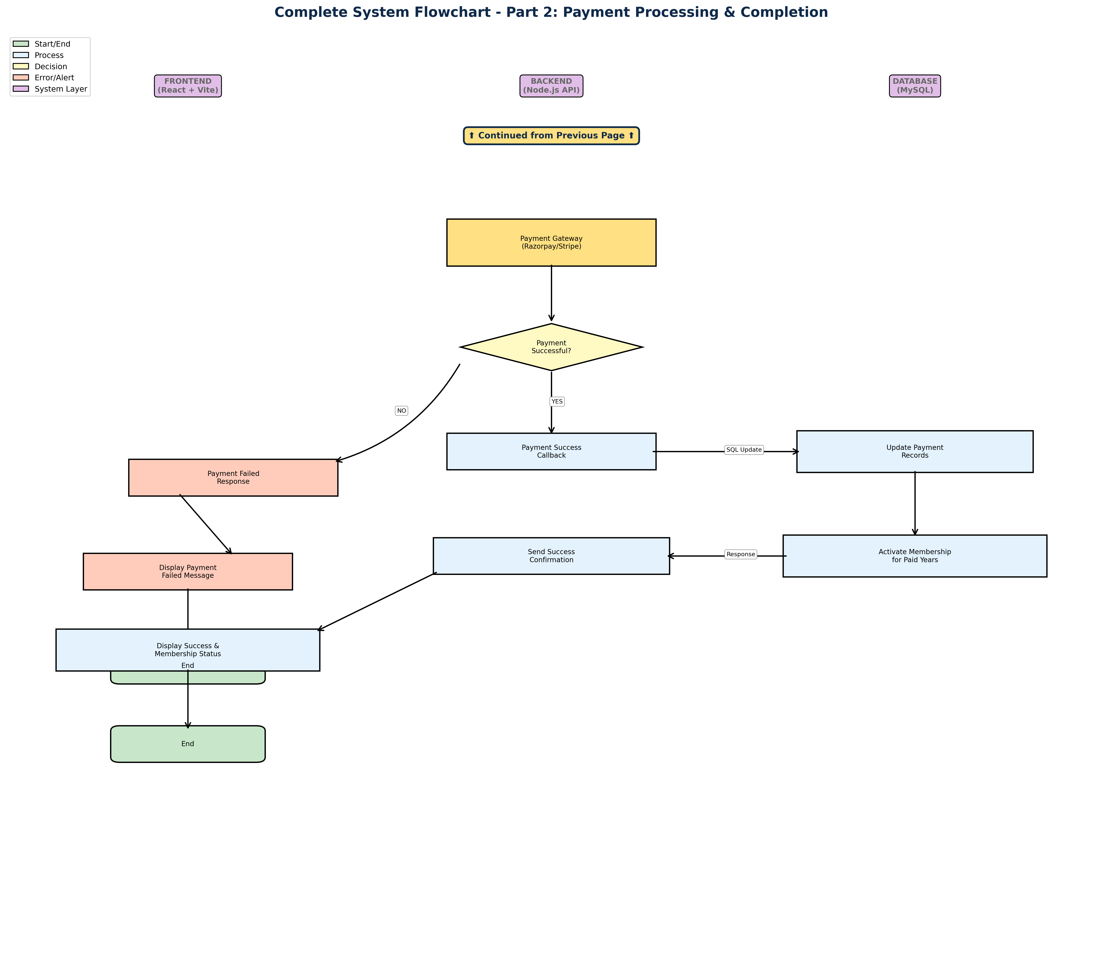

3.3 Flow Description
User Access & Search: User visits the website and searches for a member by name. The frontend sends an API request to the backend, which queries the MySQL database.
Member Verification: If the member is found, their complete details (Name, Phone, Email, Folio Number) are retrieved from the database, formatted by the backend, and displayed on the frontend.
Payment Initiation: When the user proceeds to payment, the system fetches the complete payment history from the database to determine which membership years are payable.
Payment Processing: The user is redirected to the payment gateway. Upon successful payment, the database is updated with new payment records, and the membership is activated for the paid years.

